Disdyakis Triacontahedron

Definition
# Source: AI Source: Provided by: [Data Path: Persons Table -> ID Column: 1, Name_En Column: Motasem Essam] -> From: [ChatGPT] on [7/25/2026]
A Disdyakis Triacontahedron is a convex Catalan solid with 120 congruent scalene triangular faces, 180 edges, and 62 vertices.
It is also known as the Hexakis Icosahedron. It is the dual polyhedron of the Truncated Icosidodecahedron, also called the Great Rhombicosidodecahedron, an Archimedean solid.
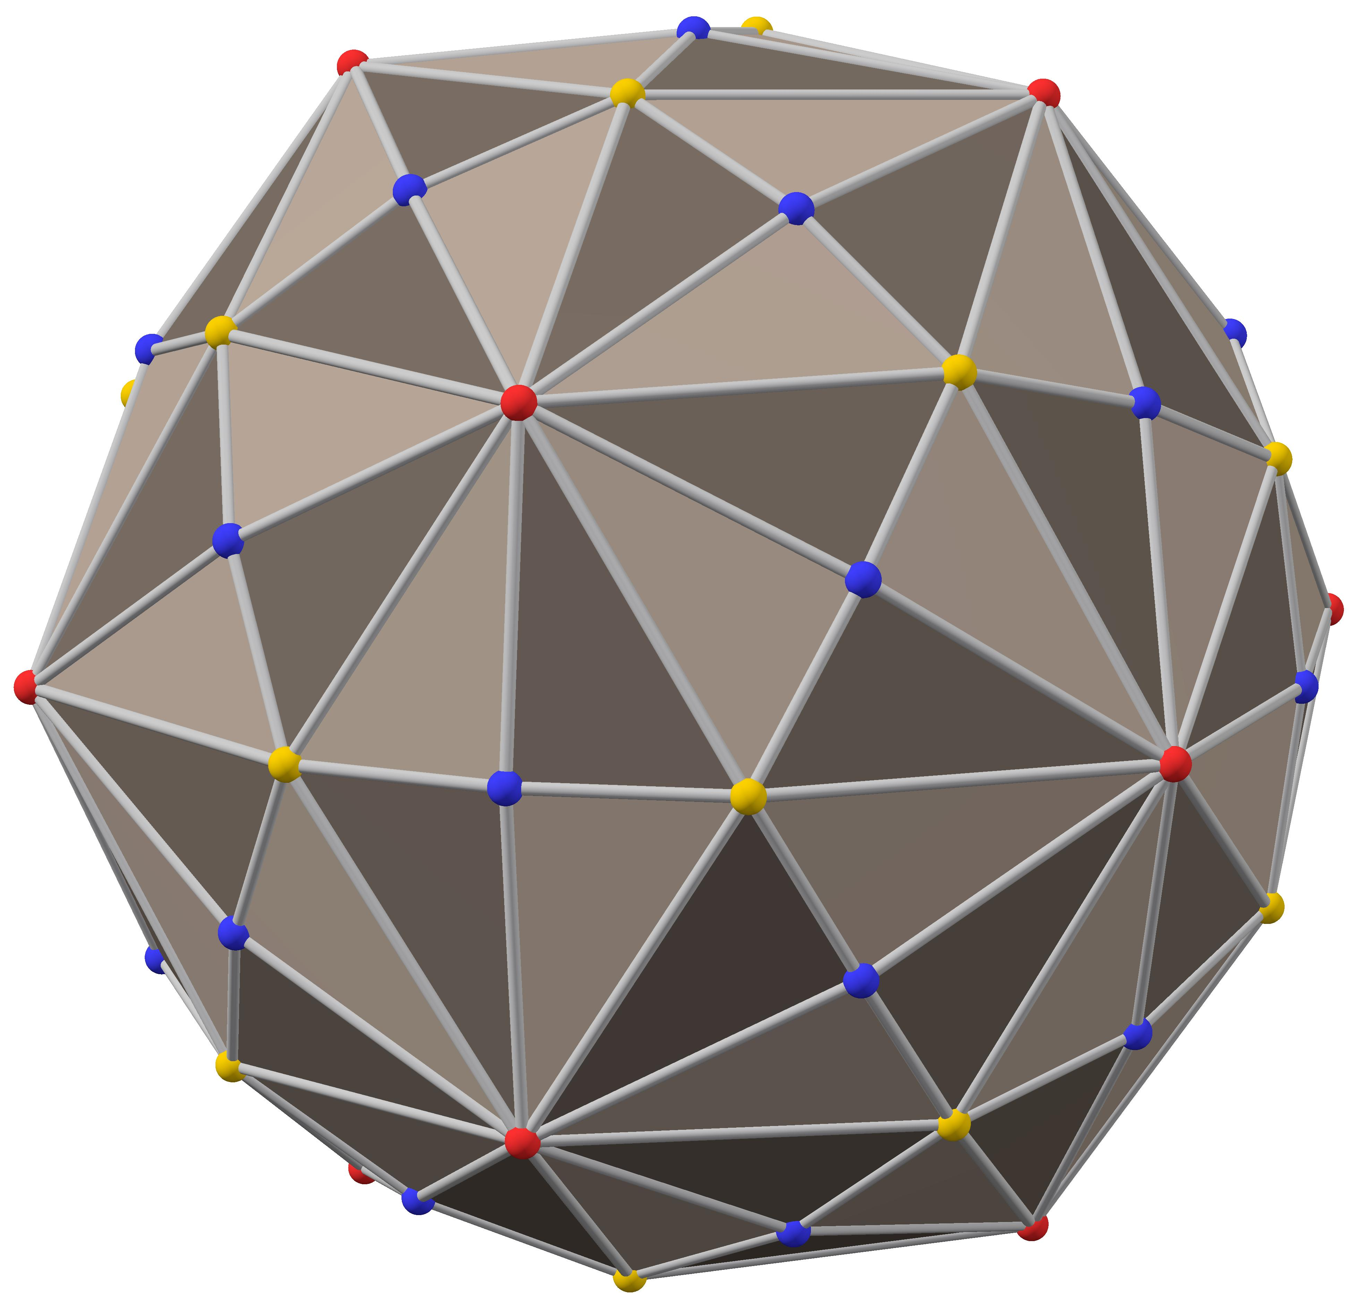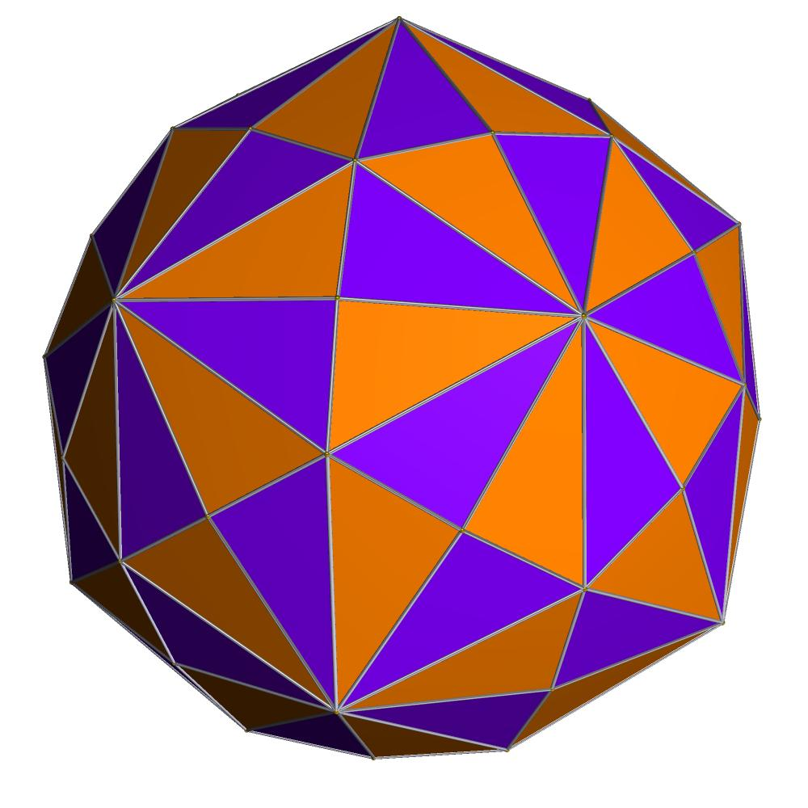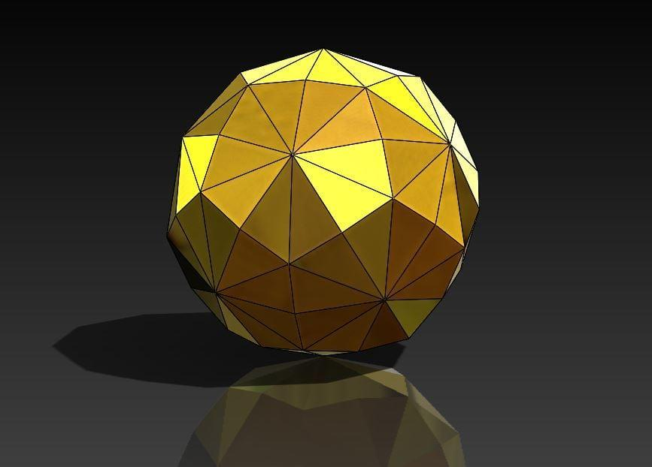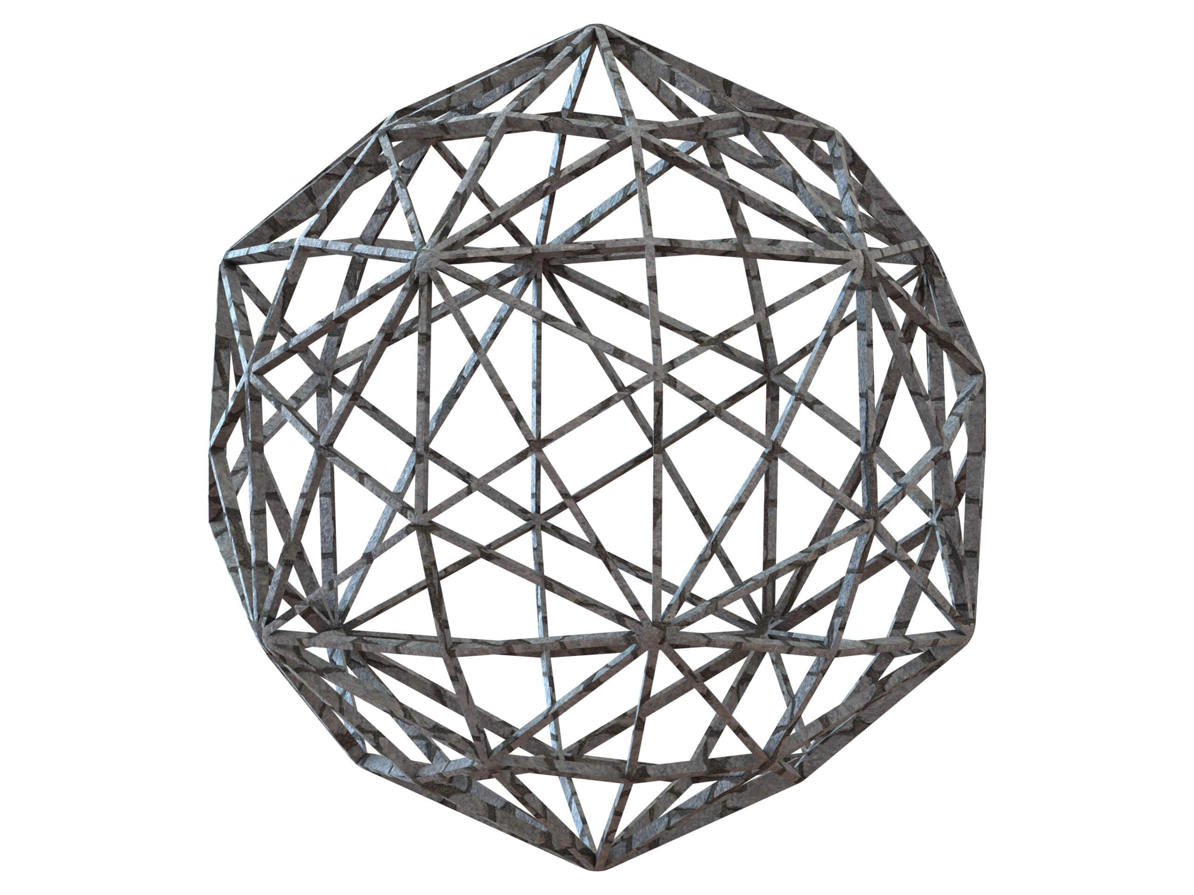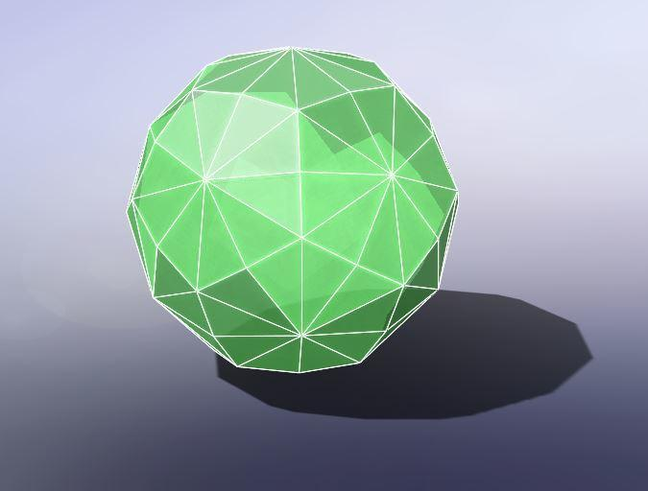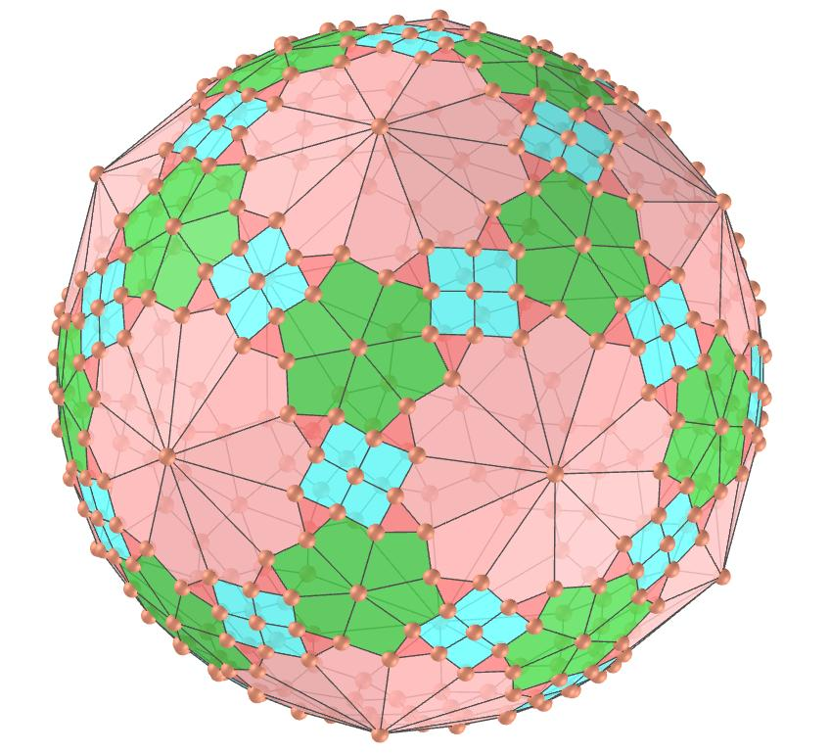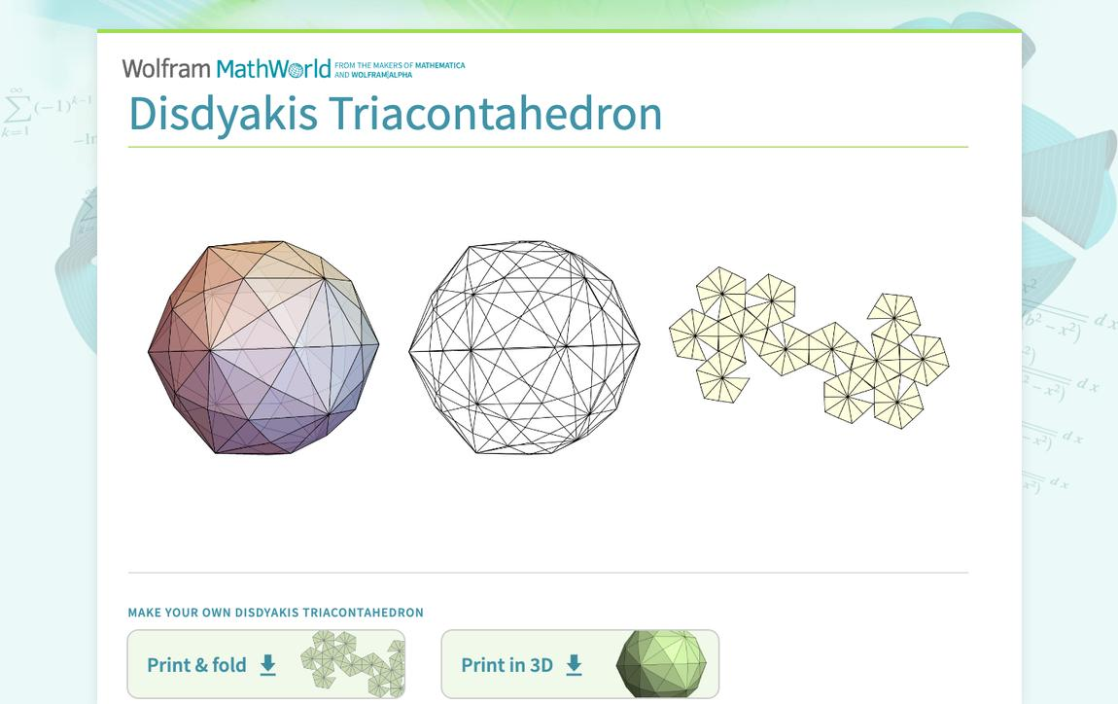

Simple Definition
# Source: AI Source: Provided by: [Data Path: Persons Table -> ID Column: 1, Name_En Column: Motasem Essam] -> From: [ChatGPT] on [7/25/2026]
The Disdyakis Triacontahedron is a complex 3D solid made entirely of 120 identical scalene triangles.
Unlike a solid with regular triangular faces, each triangle has three sides of different lengths and three different angles. The triangles meet at vertices in three different arrangements.

Geometric Structure
# Source: AI Source: Provided by: [Data Path: Persons Table -> ID Column: 1, Name_En Column: Motasem Essam] -> From: [ChatGPT] on [7/25/2026]
Its main geometric features are:
- 120 faces: all congruent scalene triangles.
- 180 edges: divided into three groups of different lengths.
- 62 vertices: divided into three groups according to the number of edges meeting at each vertex.
- Convex form: the faces enclose a solid without self-intersections.
- Icosahedral symmetry: the solid has the full symmetry of an icosahedron and dodecahedron.

Face Structure
# Source: AI Source: Provided by: [Data Path: Persons Table -> ID Column: 1, Name_En Column: Motasem Essam] -> From: [ChatGPT] on [7/25/2026]
The Disdyakis Triacontahedron has 120 congruent scalene triangular faces.
A scalene triangle has:
- Three sides of different lengths.
- Three angles of different measures.
- No equal sides or equal angles.
The three face angles are approximately:
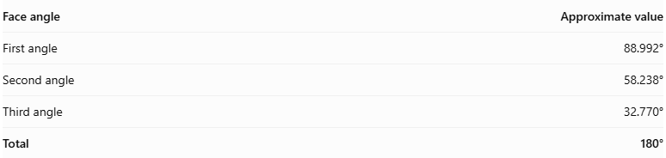
Face angle | Approximate value
First angle | 88.992°
Second angle | 58.238°
Third angle | 32.770°
Total | 180°
Although the triangles are scalene, all 120 faces have the same shape and size.

Edge Structure
# Source: AI Source: Provided by: [Data Path: Persons Table -> ID Column: 1, Name_En Column: Motasem Essam] -> From: [ChatGPT] on [7/25/2026]
The solid has 180 edges, divided into three groups:
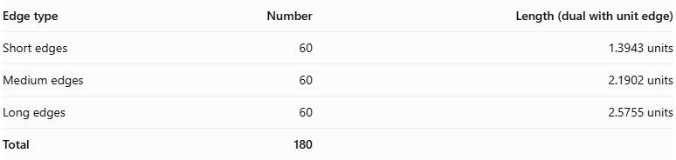
Edge type | Number | Length (dual with unit edge)
Short edges | 60 | 1.3943 units
Medium edges | 60 | 2.1902 units
Long edges | 60 | 2.5755 units
Total | 180
These lengths are for the canonical model whose dual Truncated Icosidodecahedron has edge length 1. The three groups have equal numbers of edges, but different lengths.

Vertex Structure
# Source: AI Source: Provided by: [Data Path: Persons Table -> ID Column: 1, Name_En Column: Motasem Essam] -> From: [ChatGPT] on [7/25/2026]
The Disdyakis Triacontahedron has 62 vertices, divided into three groups:
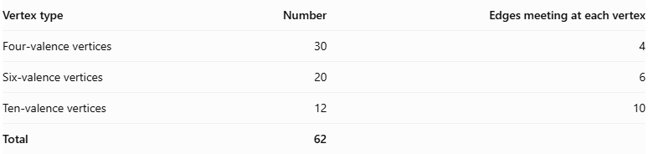
Vertex type | Number | Edges meeting at each vertex
Four-valence vertices | 30 | 4
Six-valence vertices | 20 | 6
Ten-valence vertices | 12 | 10
Total | 62
- 30 four-valence vertices: four edges and four triangular faces meet at each vertex.
- 20 six-valence vertices: six edges and six triangular faces meet at each vertex.
- 12 ten-valence vertices: ten edges and ten triangular faces meet at each vertex.
These vertex groups correspond to the vertices of an inscribed icosidodecahedron, dodecahedron, and icosahedron, respectively.
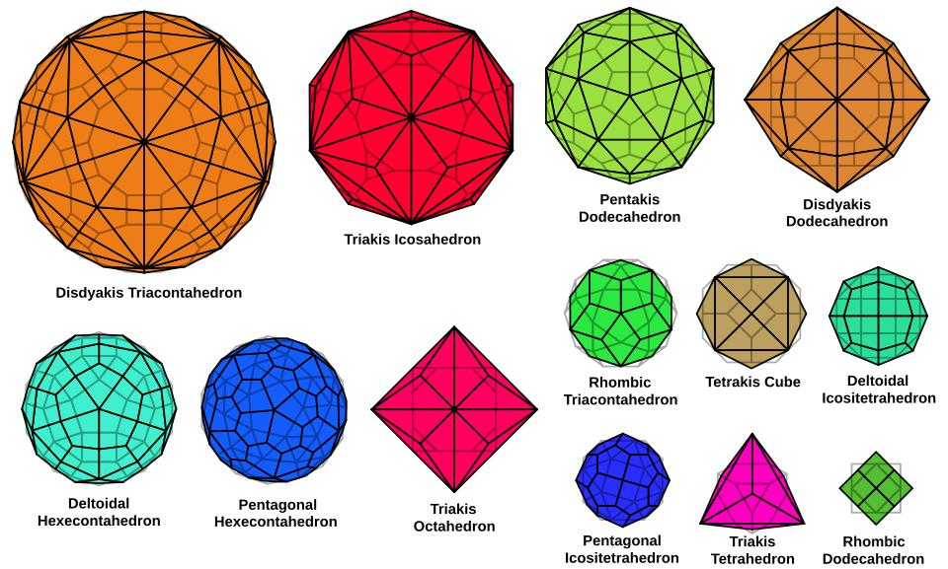

Mathematical Properties
# Source: AI Source: Provided by: [Data Path: Persons Table -> ID Column: 1, Name_En Column: Motasem Essam] -> From: [ChatGPT] on [7/25/2026]
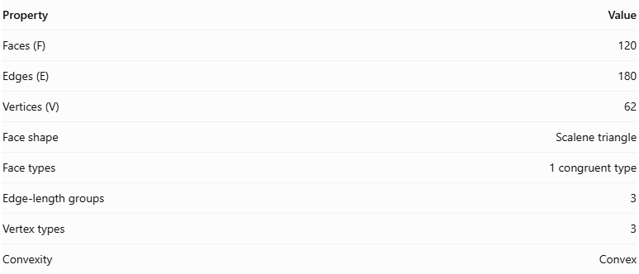
Property | Value
Faces (F) | 120
Edges (E) | 180
Vertices (V) | 62
Face shape | Scalene triangle
Face types | 1 congruent type
Edge-length groups | 3
Vertex types | 3
Convexity | Convex
Euler's formula
For a convex polyhedron:
$$V-E+F=2$$
Substituting the values:
$$62-180+120=2$$
Therefore, the Disdyakis Triacontahedron satisfies Euler's polyhedron formula.
Dihedral angle
All edges have the same dihedral angle, even though the edges have three different lengths:
$$θ=\cos^{-1}\left(-\frac{179+24\sqrt{5}}{241}\right)$$
$$\boxed{θ≈{164.888}^{°}}$$

Symmetry
# Source: AI Source: Provided by: [Data Path: Persons Table -> ID Column: 1, Name_En Column: Motasem Essam] -> From: [ChatGPT] on [7/25/2026]
The Disdyakis Triacontahedron has full icosahedral symmetry, denoted by $I_{h}$.
Its symmetry includes:
- Fivefold rotational axes.
- Threefold rotational axes.
- Twofold rotational axes.
- Reflection symmetries.
- Inversion symmetry.
It has the same full symmetry group as the regular icosahedron and regular dodecahedron.

Surface Area and Volume
# Source: AI Source: Provided by: [Data Path: Persons Table -> ID Column: 1, Name_En Column: Motasem Essam] -> From: [ChatGPT] on [7/25/2026]
The surface area and volume depend on the scale of the solid.
For the canonical Disdyakis Triacontahedron whose dual Truncated Icosidodecahedron has edge length 1, the volume is:
$$V=\frac{180(5+4\sqrt{5})}{11}$$
$$\boxed{V≈228.1790}$$
This volume is expressed in cubic units under that specific normalization. If the model is scaled by a factor $k$, its surface area scales by $k^{2}$, and its volume by $k^{3}$.

Relationship to Other Solids
# Source: AI Source: Provided by: [Data Path: Persons Table -> ID Column: 1, Name_En Column: Motasem Essam] -> From: [ChatGPT] on [7/25/2026]
The Disdyakis Triacontahedron is the dual of the Truncated Icosidodecahedron, also known as the Great Rhombicosidodecahedron.
Disdyakis Triacontahedron
- 120 faces
- 180 edges
- 62 vertices
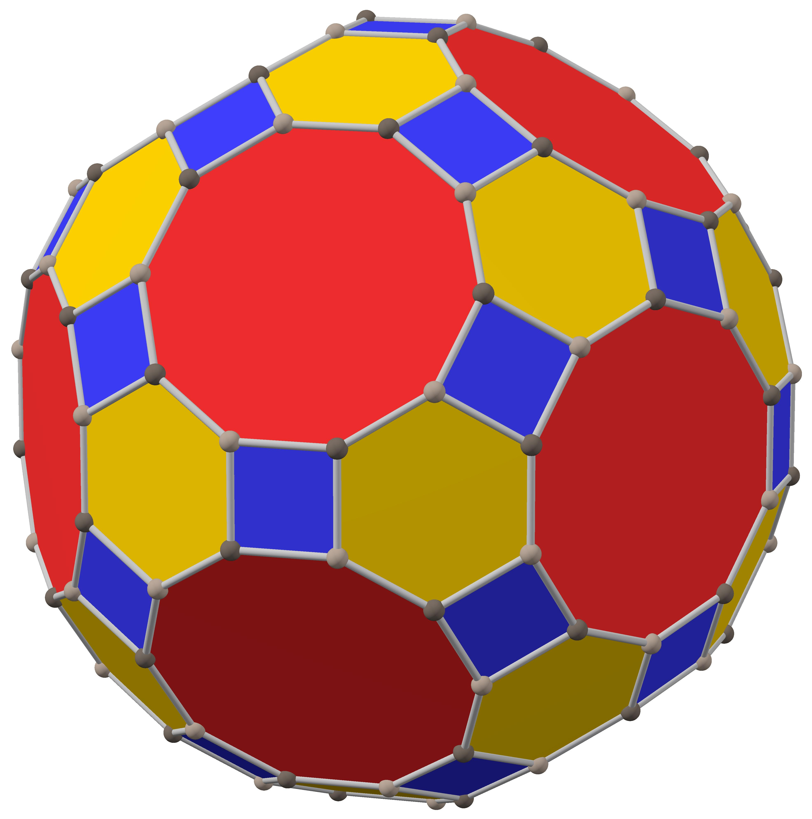
Truncated Icosidodecahedron
- 62 faces
- 180 edges
- 120 vertices
In dual polyhedra:
- Each face of one solid corresponds to a vertex of the other.
- Each vertex corresponds to a face.
- Both solids have the same number of edges.

Constructing a Disdyakis Triacontahedron

Geometric Instruments Used
# Source: AI Source: Provided by: [Data Path: Persons Table -> ID Column: 1, Name_En Column: Motasem Essam] -> From: [ChatGPT] on [7/25/2026]
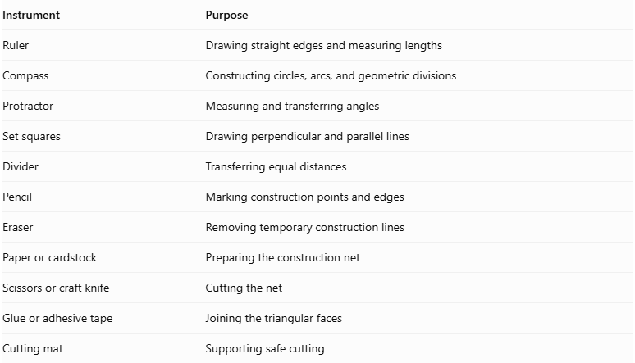
Instrument | Purpose
Ruler | Drawing straight edges and measuring lengths
Compass | Constructing circles, arcs, and geometric divisions
Protractor | Measuring and transferring angles
Set squares | Drawing perpendicular and parallel lines
Divider | Transferring equal distances
Pencil | Marking construction points and edges
Eraser | Removing temporary construction lines
Paper or cardstock | Preparing the construction net
Scissors or craft knife | Cutting the net
Glue or adhesive tape | Joining the triangular faces
Cutting mat | Supporting safe cutting

Instrument-Based Construction Procedures
# Source: AI Source: Provided by: [Data Path: Persons Table -> ID Column: 1, Name_En Column: Motasem Essam] -> From: [ChatGPT] on [7/25/2026]
There are three practical geometric approaches to constructing the Disdyakis Triacontahedron.

Method 1: Construction Using a Triangular Net
# Source: AI Source: Provided by: [Data Path: Persons Table -> ID Column: 1, Name_En Column: Motasem Essam] -> From: [ChatGPT] on [7/25/2026]
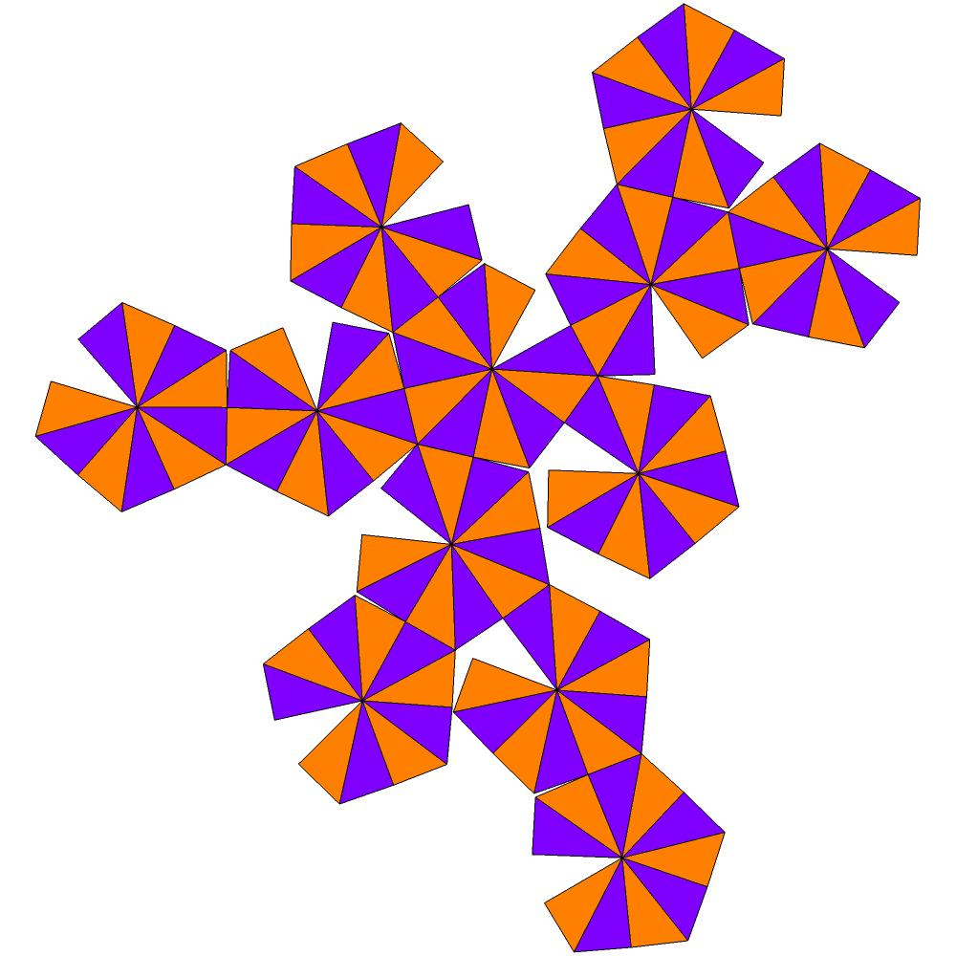
- Determine the edge lengths: Establish the short, medium, and long edge measurements using the required edge-length ratio.
- Construct the triangular faces: Use a ruler, compass, and protractor to draw 120 congruent scalene triangles.
- Arrange the triangular faces: Organize the triangles according to a valid unfolding of the polyhedron.
- Mark the joining edges: Identify which edges must connect when the net is folded.
- Add joining tabs: Include tabs along selected external edges to make assembly possible.
- Cut out the net: Carefully cut around the external boundary.
- Fold the faces: Fold along the designated edges to form the three-dimensional structure.
- Join the edges: Attach matching edges using glue or adhesive tape.
- Complete the solid: Check that all 120 triangular faces meet correctly.

Method 2: Construction by Augmenting a Rhombic Triacontahedron
# Source: AI Source: Provided by: [Data Path: Persons Table -> ID Column: 1, Name_En Column: Motasem Essam] -> From: [ChatGPT] on [7/25/2026]
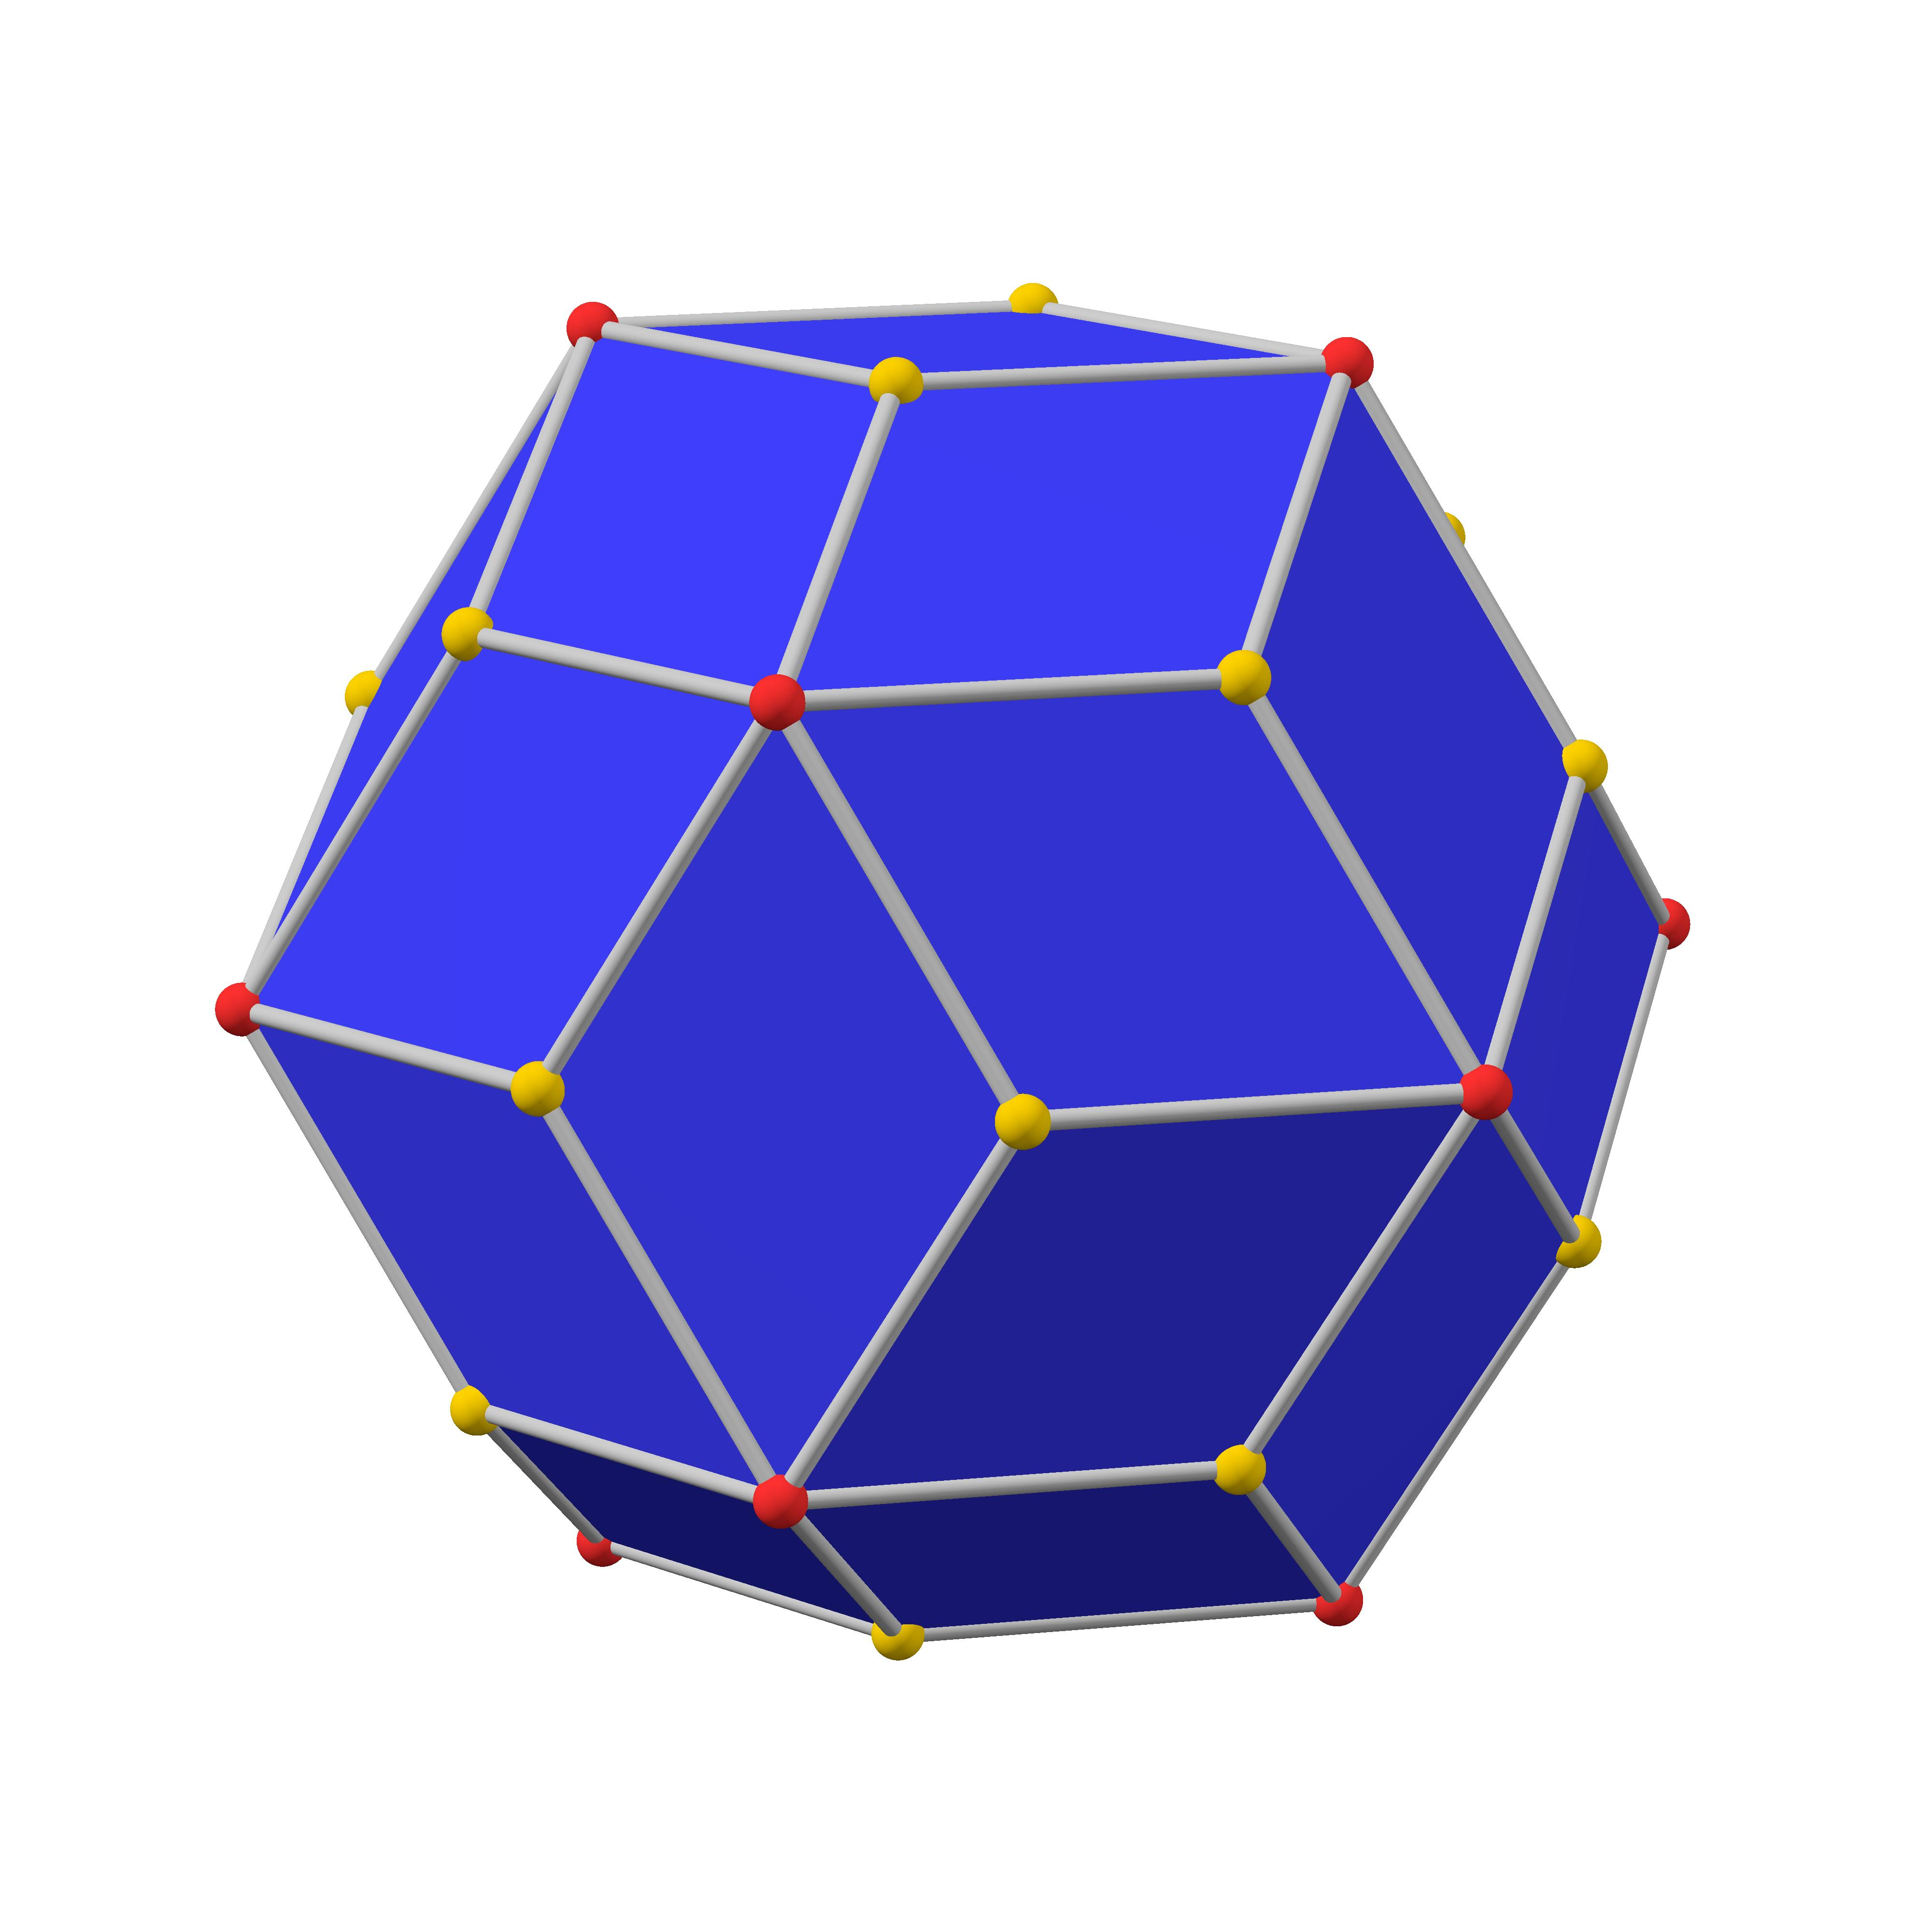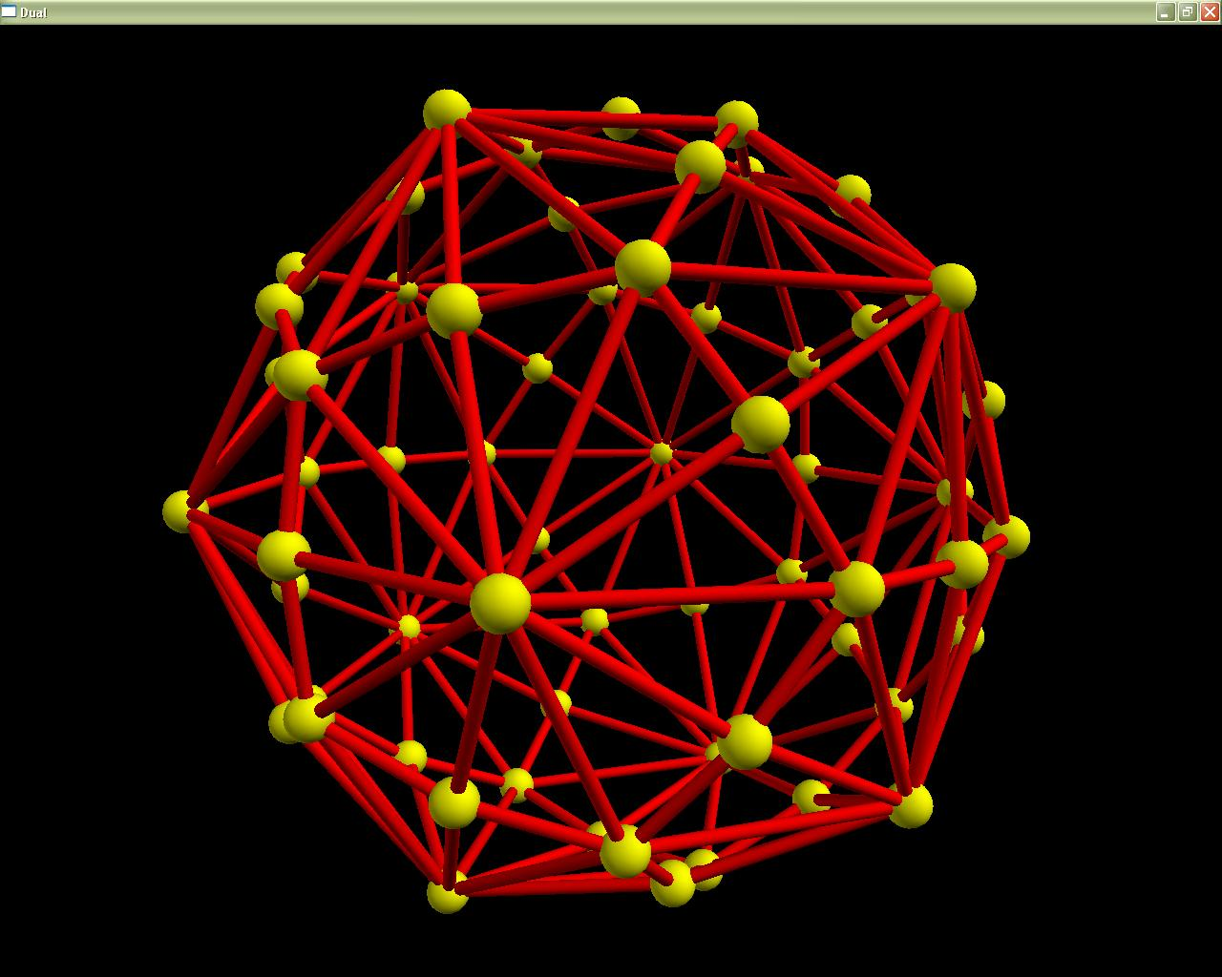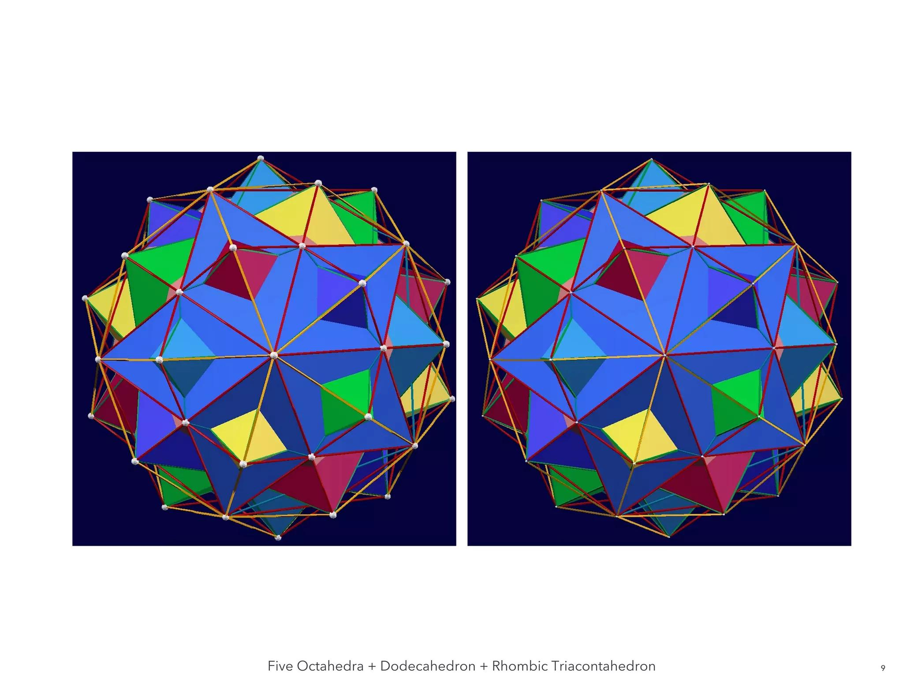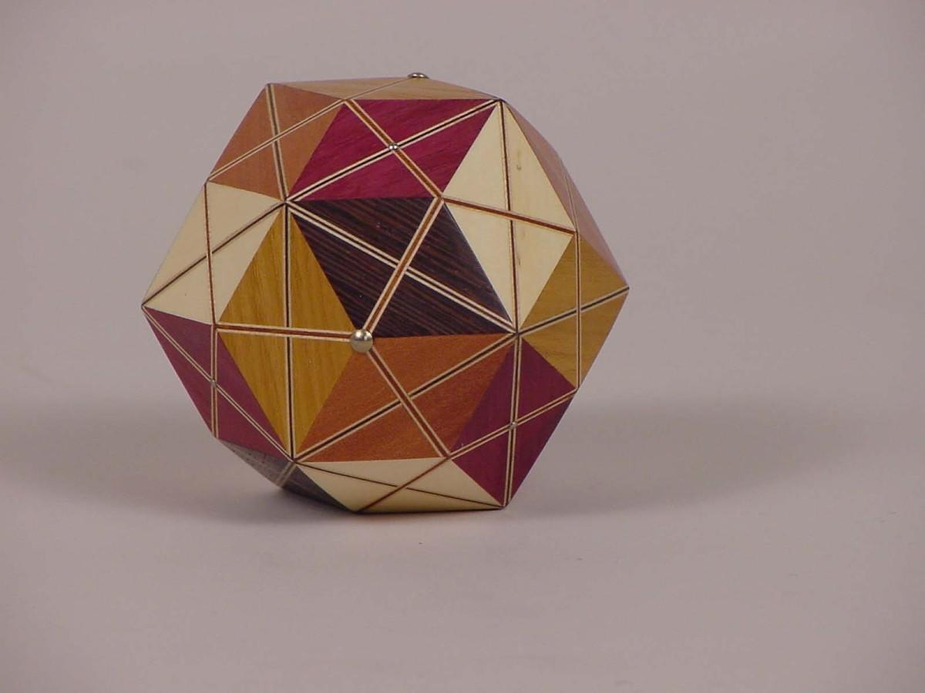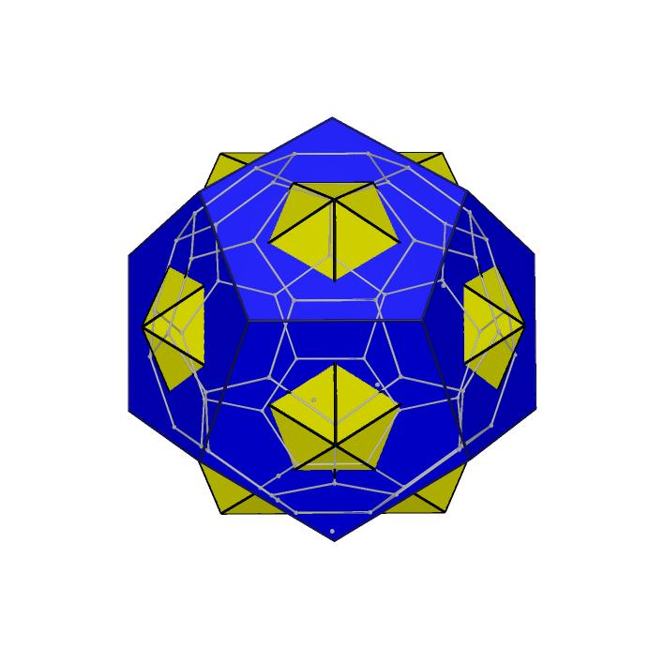
This method uses the Kleetope construction, in which a pyramid is attached to each face of an existing polyhedron.
- Construct a Rhombic Triacontahedron: Draw and assemble its 30 congruent rhombic faces.
- Identify the rhombic faces: Mark the four vertices and center of each of the 30 rhombi.
- Determine the pyramid height: Establish the required height so that the resulting triangular faces are congruent to one another.
- Construct the apex points: Mark one apex above each rhombic face.
- Connect each apex to the rhombus vertices: Draw four segments from each apex to the four vertices of its corresponding rhombus.
- Divide each rhombic face: The four connections form four triangular faces for each original rhombus.
- Repeat for all 30 faces: Construct the pyramidal structures over every rhombic face.
- Verify the completed solid: Confirm that it contains 120 congruent scalene triangles, 180 edges, and 62 vertices.
Construction principle: 30 rhombic faces × 4 triangular faces per rhombus = 120 triangular faces.

Method 3: Construction Through the Dual of a Truncated Icosidodecahedron
# Source: AI Source: Provided by: [Data Path: Persons Table -> ID Column: 1, Name_En Column: Motasem Essam] -> From: [ChatGPT] on [7/25/2026]
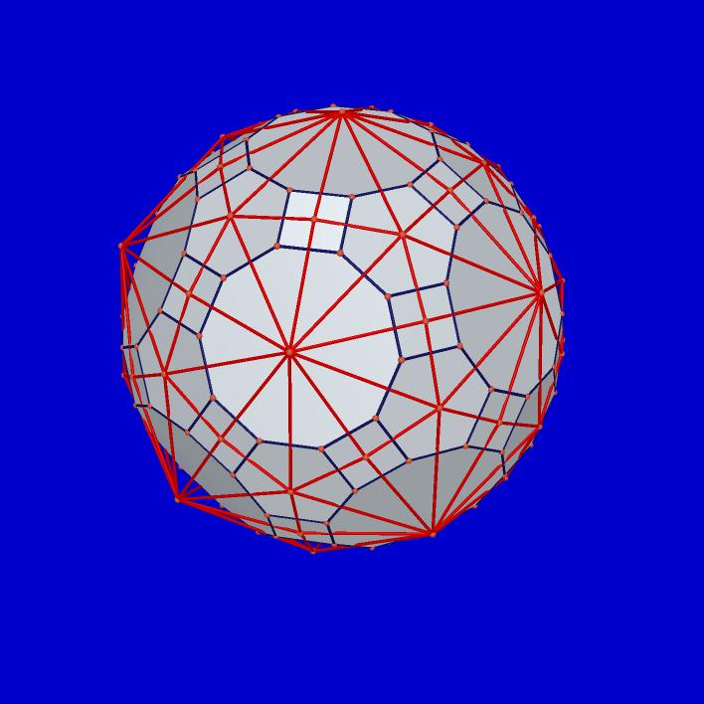
- Construct a Truncated Icosidodecahedron: Establish its regular square, hexagonal, and decagonal faces using geometric drawing instruments.
- Identify its faces: Locate the 30 square faces, 20 hexagonal faces, and 12 decagonal faces.
- Construct the face-center points: Mark the center of each face.
- Establish the dual vertices: Construct one dual vertex corresponding to each original face.
- Determine the dual connections: Connect dual vertices corresponding to adjacent faces of the original polyhedron.
- Construct the triangular faces: Each original vertex is surrounded by three faces, producing one triangular face in the dual.
- Apply the correct dual scaling: Use a polar-dual construction or the appropriate reciprocal-plane distances. Ordinary face centers alone do not necessarily produce the standard dual.
- Complete the construction: Verify the 120 triangular faces, 180 edges, and 62 vertices.
The original solid's 30 square, 20 hexagonal, and 12 decagonal faces correspond to the dual's 30 four-valent, 20 six-valent, and 12 ten-valent vertices, respectively.

Key Points
# Source: AI Source: Provided by: [Data Path: Persons Table -> ID Column: 1, Name_En Column: Motasem Essam] -> From: [ChatGPT] on [7/25/2026]
- The Disdyakis Triacontahedron is one of the 13 Catalan solids.
- It has 120 congruent scalene triangular faces.
- It has 180 edges and 62 vertices.
- Its edges have three different lengths, with 60 edges in each group.
- It has three vertex types: 30 vertices of valence 4, 20 of valence 6, and 12 of valence 10.
- It is the dual of the Truncated Icosidodecahedron.
- It has full icosahedral symmetry $I_{h}$.
- It is a convex polyhedron.

Conclusion
# Source: AI Source: Provided by: [Data Path: Persons Table -> ID Column: 1, Name_En Column: Motasem Essam] -> From: [ChatGPT] on [7/25/2026]
The Disdyakis Triacontahedron is a highly symmetrical Catalan solid distinguished by its 120 congruent scalene triangular faces, three edge-length groups, and three different vertex configurations. Its dual relationship with the Truncated Icosidodecahedron makes it an important example of polyhedral duality and icosahedral symmetry.

References
# Source: AI Source: Provided by: [Data Path: Persons Table -> ID Column: 1, Name_En Column: Motasem Essam] -> From: [ChatGPT] on [7/25/2026]
- Wolfram MathWorld – Disdyakis Triacontahedron.
- David McCooey – Disdyakis Triacontahedron.
- QFBox – The Disdyakis Triacontahedron.
- Disdyakis Triacontahedron – Geometry and Face Angles.
- MacTutor – Catalan Solids.

